**Environment Setup**

**Docker Account Creation**

|  |  |
| --- | --- |
| Team ID | PNT2022TMID14714 |
| Project Name | Nutrition Assistant Application |

**Josephine Cynthia L**

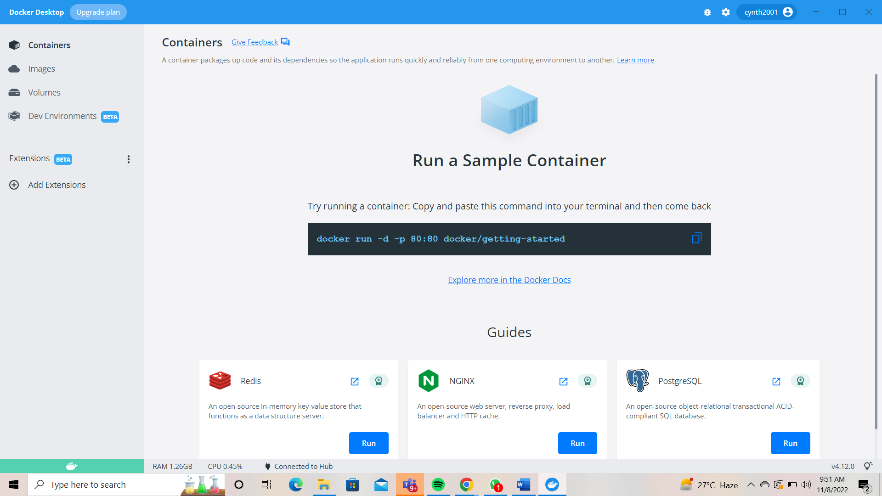

**Abarna**

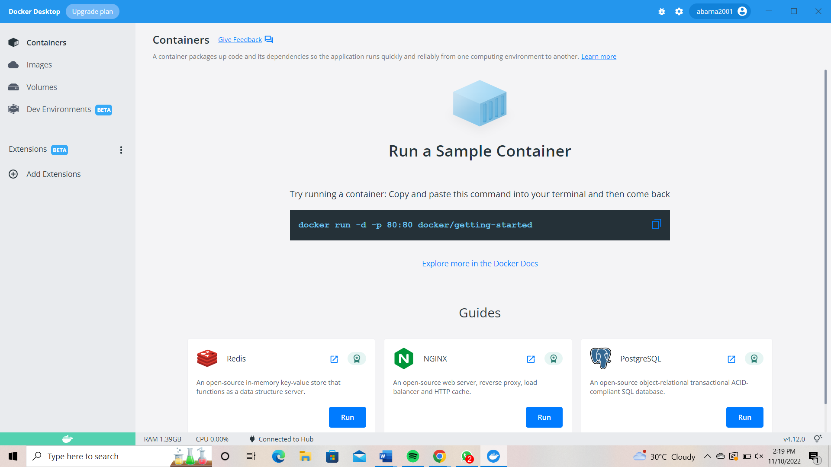

**Archana**

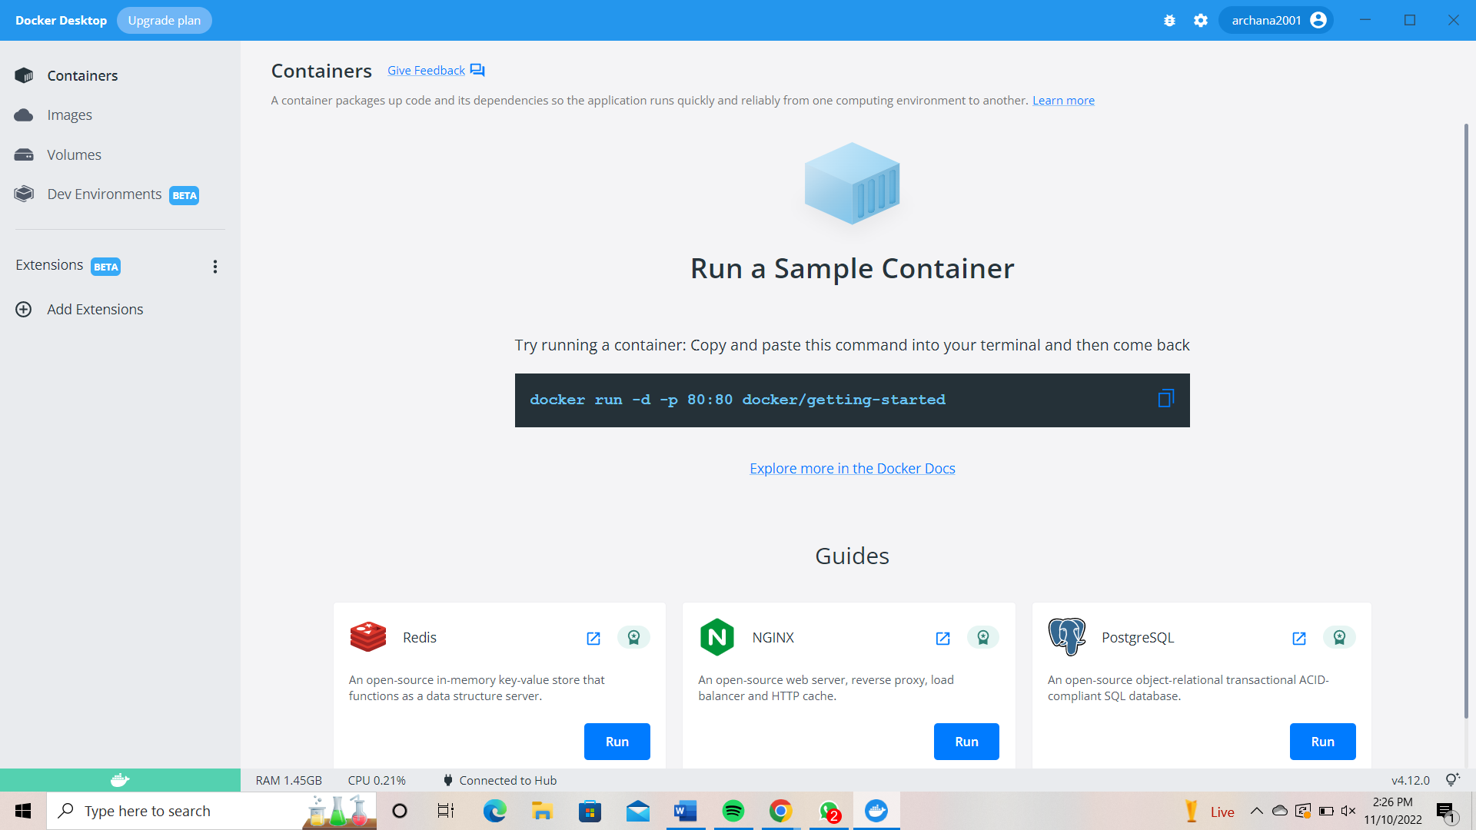

**Vishal**

